FMA
WEB AUTHORING
-
EMBLEM COLLECTIBLE BOOKS

Name: Manuel Piatesi
Due date: 02-08-16
Module: Advanced Web Authoring
Tutor: Marcel Krajca

TABLE OF CONTENTS
WEBSITE URL……………………………………………………………………………………………………………3
BROWSER COMPATIBILITY…….…………………………………………………………………………………3
HTML5 SHIV……………………………………………………………………………………………………..3
CSS RESET………………………………………………………………………………………………………..4
EMBEDDING……..……………………………………………………………………………………………..4
WEAKNESS……………………………………………………………………………………………………….5
MEDIA QUERIES………………………………………………………………………………………….5
BOX/TEXT SHADOW – BORDER RADIUS………………………………………………………………..5
PLACEHOLDERS………………………………………………………………………………………….5
ACCESSIBILITY ………………………………………….…………………………………………………………….5
TECHNICAL STANDARDS………………………………………….………………………………………….6
DESIGN STANDARDS………………………………………….……………………………………………...7
WEAKNESS………………………………………….…………….…………………………….……….8

REFERENCES……………………………………………………………….………………………………………….8

Website url
http://titan.dcs.bbk.ac.uk/~mpiate01/wafma/index.html

Browser compatibility
The website has been built following common techniques to guarantee its full functionality regardless of the browser that user might use.

HTML5 Shiv
Html5 has been used to build the skeleton of the webpage, but not all its features are fully supported by older browsers. In the website tags such as “header”, ”main”, “footer”, “nav”, “section”, “article” and “aside” have been used but they are treated as unknown elements for a browser such as IE6, hence they cannot be properly styled unless a JavaScript file is used. Therefore, to overcome this issue, a conditional comment has been used, in the “head” tag, to target IE versions lower than 9 and apply the “HTML5 shiv” script to allow html5 tags to be styled with CSS.
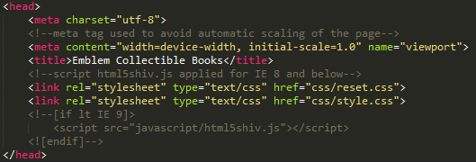
Fig. 1. Conditional comment for IE < 9.
The “HTML5 shiv” has been applied only to IE < 9 and not as default to improve the speed of rendering the webpages. The CSS files are loaded only after the script to avoid the “flashing” issue of changing styling of the page’s elements while loading the webpage that I had firstly while testing the page with IE11.
The script alone is not enough for the website to display all the new html5 tags. The reset CSS file has to include a declaration block targeting the new HTML5, otherwise all versions of IE won’t be able to properly display them. I have encountered this issue testing the website with IE11 and I managed to overcome the “bug” by visiting the website http://stackoverflow.com.

CSS Reset
Every browser applies default styles to all HTML elements. Therefore to avoid cross-browser differences as much as possible, a CSS reset file has been created and loaded before the “custom” CSS file.

Embedding
The website has been built embedding a font and a video file, but older browsers might not support all format types. Therefore for maximum browser support, I have included different formats for font and video for both modern and old browsers.
The five font formats are:
- format("embedded-opentype") for IE6-IE8;
- format("woff") for modern Browsers;
- format("truetype") for Safari, Android, iOS;
- format("svg") for old iOS;
- format(“eot") for IE9.
The four video formats are:
- type="video/webm" for Firefox, Chrome, Opera;
- type="video/mp4" for IE, Safari and some versions of Chrome/Firefox;
- type="video/ogg"for old versions of Firefox;
- downloadable video.
I have encountered an issue in applying the custom font. Earlier I had written the declaration CSS code for embedding the font in a different order and it was not working properly. I have resolved the issue as it follows:
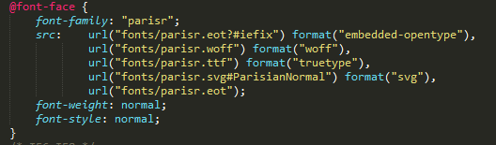
Fig. 2. Font embedding.

Weakness
Media Queries
A weakness of the website’ styling might be found in the media queries used to display the pages. Media features are not supported in the old version of IE therefore the page cannot be display properly accordingly to different device widths. During the testing phase “screen/9” has been added to the media queries and it seems to have improved the website’s view with IE8 and IE7, but the layout still breaks with IE6. Furthermore, the main navigation bar layout breaks by using IE8.

Box/Text shadow – Border radius
CSS features as box/text shadow and border radius are supported only with IE version 9 and more, therefore if an older IE would be used, the company logo and other elements of the website will not be displayed properly and the page layout would change. A way to overcome this issue would be to use images instead of those properties.

Placeholder
The placeholder properties have been used to increase accessibility and “webkits” have been used to guarantee cross-compatibility, but unfortunately it could not be tested properly in older IE versions.
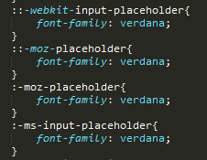
Fig. 3. Placeholder.

Accessibility
The website has been built to be accessible to people with diverse abilities and technology access.
An online tool, wave.webaim.org, has been use to test the accessibility of the website. It highlights strengths and weaknesses based on the best techniques recommended by W3C.

Technical standards

Technical standards have been used to optimise the site accessibility for people using screen readers and keyboards/joysticks.
For screen readers, ARIA landmarks roles have been added to semantic mark-ups to enable users to navigate to specific areas of the page and to describe individual elements and their relationship.

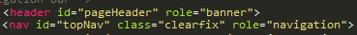
Fig.4 Aria roles.

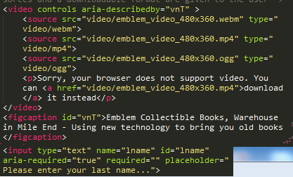
Fig.5 Aria landmark for describe elements.

The online tool has been useful for detecting “orphan” sections with a landmark role missing and fixing it. Furthermore, the attribute scope has been added to help users in “reading” tables.

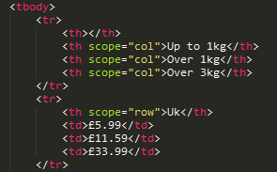
Fig.6 Scope attribute for tables.

To display delivery charges, a description list has been used instead of another type of list with the same goal of improving readability.
The website contains also “skip links” and “back to top links” to improve user experience while using only keyboards or joysticks. They are used to skip straight away to the “interesting” content of the page (they are only visible while “focused”).

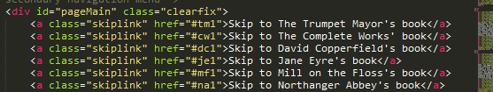
Fig. 6 Example of skip links.

Design standards

The website includes a form and it is important to help users in filling it out. Therefore the form has been built with design features to improve accessibility in terms of showing required fields and errors and helps on filling the field out (placeholder property). A different colour has been used when a required field has been selected and the aria property “required” has been added for screen reader users.

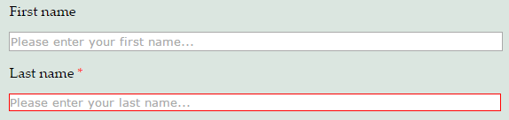
Fig.7 Form enanchement.

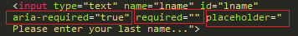
Fig.8 Example of a required field and placeholder property

Media queries have been used to guarantee the same experience regardless of the device used to display the website. They have been chosen by studying all the breaking points of the design and changing the CSS properties accordingly. A semantic mark-up and CSS properties help to keep the layout fluid while resizing the page.

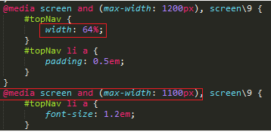
Fig.9 Example of CSS properties

Weaknesses

The online tool highlights few issues regarding readability and layout display.
Generally, the choice of colours is acceptable, but there could be an issue for some users if reading text with a “gold” colour over a “light blue” background. To improve readability a big font-size has been chosen.
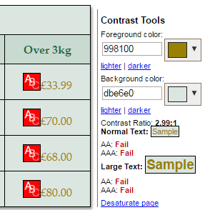
Fig. 10 Colour tool.

Another issue regards the form “resizing-capability”. Unfortunately, the form does not resize properly when the total device’s width is less than 300px even if all the coding standards have been applied. Furthermore there is a slight change of display of the required fields while “on focus”. This issue can be considered either a quality or bug of the design. It might be considered a quality because it helps the user to focus his attention on it.

References
https://css-tricks.com.
http://stackoverflow.com.
http://wave.webaim.org.

